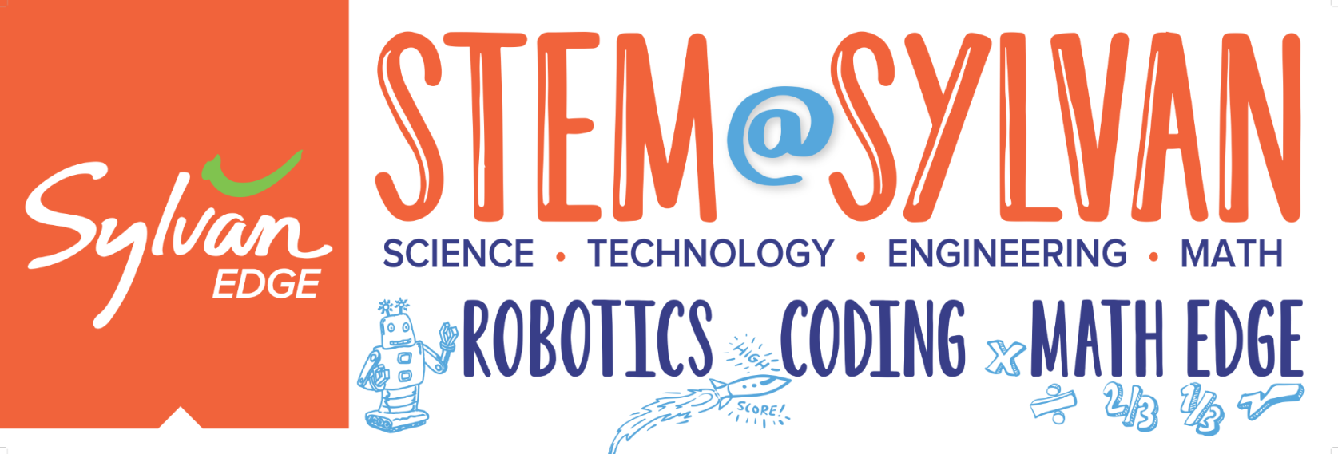
Students entering grades 2-7 welcome. All sessions occur Monday-Friday of the given week.
Session 1 – 10:00am-11:30am – Coding ∙ Session 2 – 12:00pm-1:30pm – Project 1 ∙ Session 3 – 1:30pm-3:00pm – Project 2
SPRING BREAK | JUNE 11-15 | JUNE 25-29
Robotics – 100s | Engineering – 100s | Robotics - 100s

JULY 16-20 | JULY 23-27 | JULY 30-AUG 3
Engineering – 200s | Writer’s Workshop* | Robotics – 200s
*Writer’s Workshop/Story-Telling Camp is half-day registration only. Instead of afternoon building projects, campers will practice their writing skills and the editing process.

PRICING and PERKS (weekly rates per camper**)
1 session-90 minutes Registration | 2 sessions-3 hours (half day) Registration | 3 sessions-4.5 hours (full day) Registration
$150 | $249 | $299
Budget-friendly rate! | $50 Savings | $150 Savings +  free t-shirt!
**$10 registration fee per student will cover all class materials, project badge & free academic assessment. Waived for active/ past Sylvan academic families.*
SYLVAN OF FRISCO
FRISCO@SYLVANSW.COM
214.618.2955

